**EXP 15)**Create a Cloning of a VM and Test it by loading the Previous Version/Cloned VM

**PROCEURE:**

**STEP 1:** install VM ware software

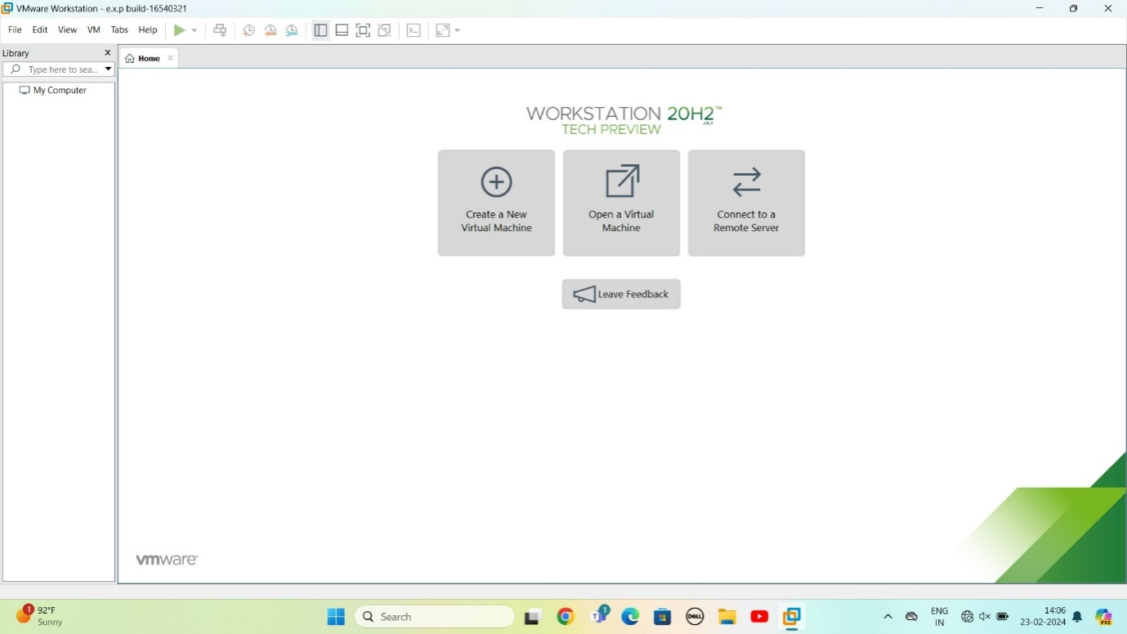

Step 2: CREAT A NEW VIRTUAL MACHINE

GIVE NEXT

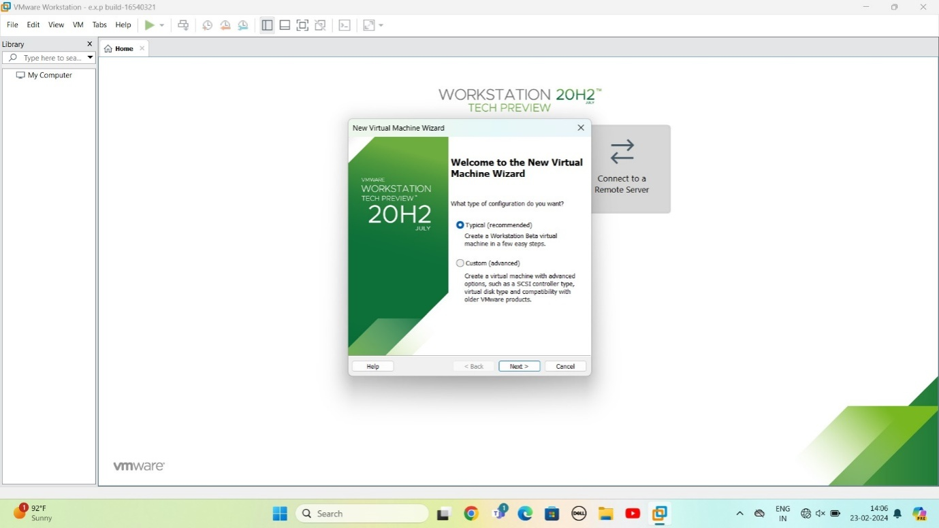

STEP 3: Select I will install operating system later

Give next

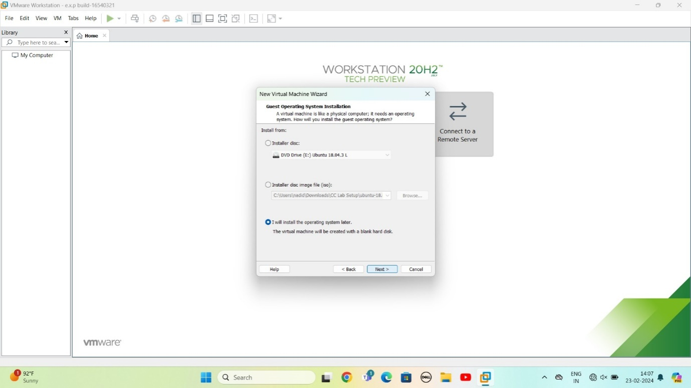

STEP 4: Select gust operating system

Give next

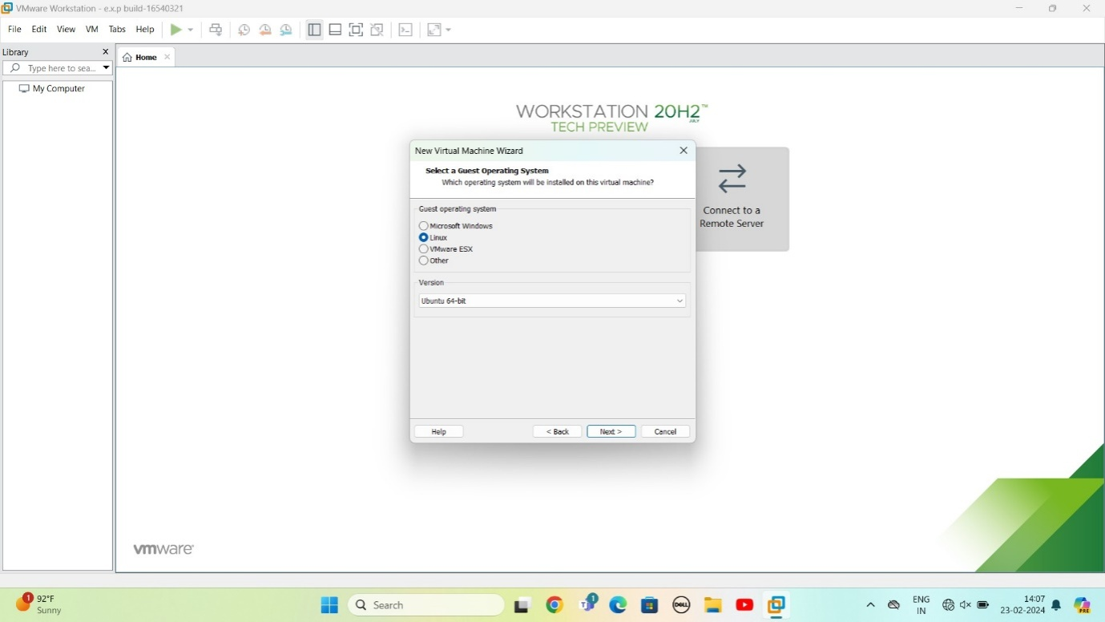

STEP 5: select name of virtual machine

Give next

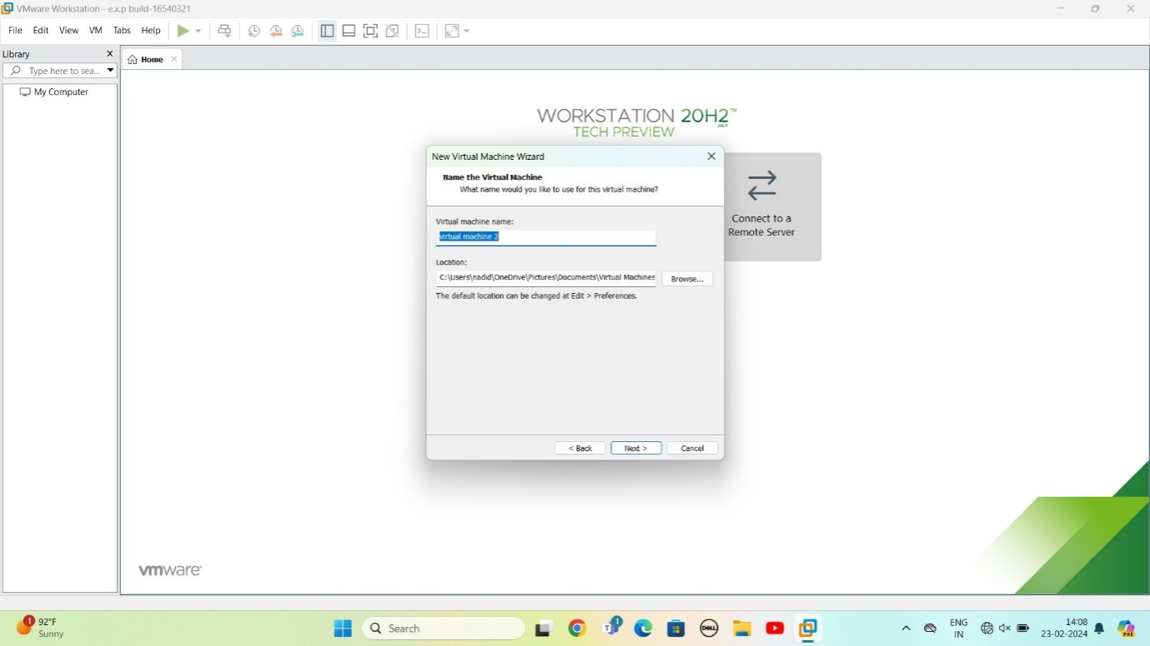

STEP 6: select the data storing disk and maximum size of disk

Give next

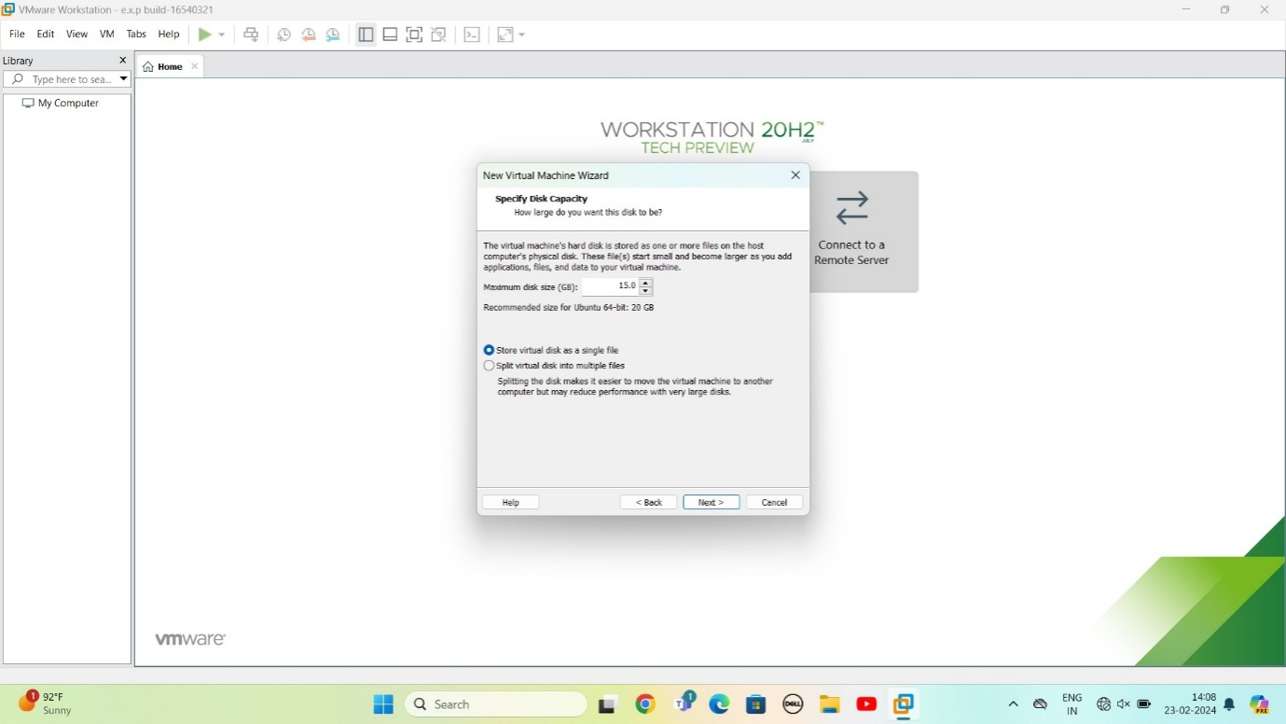

STEP 7:Ready to create virtual machine

Give finish

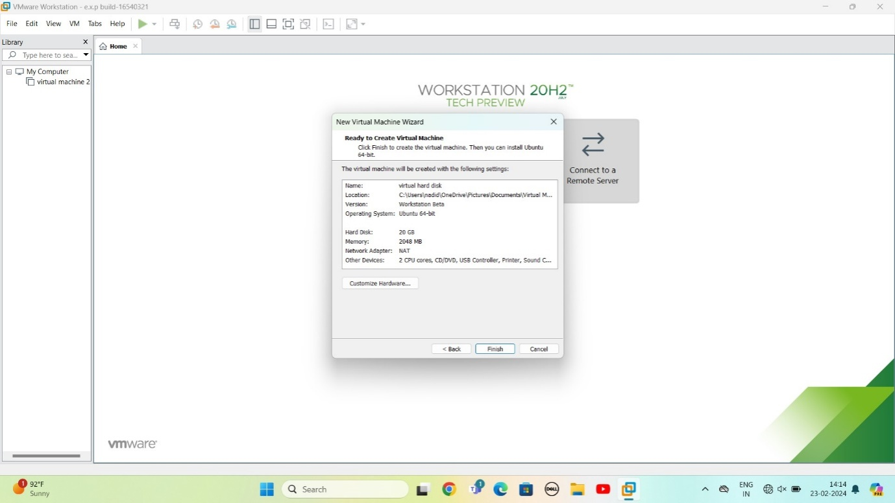

STEP 8: created the virtual machine

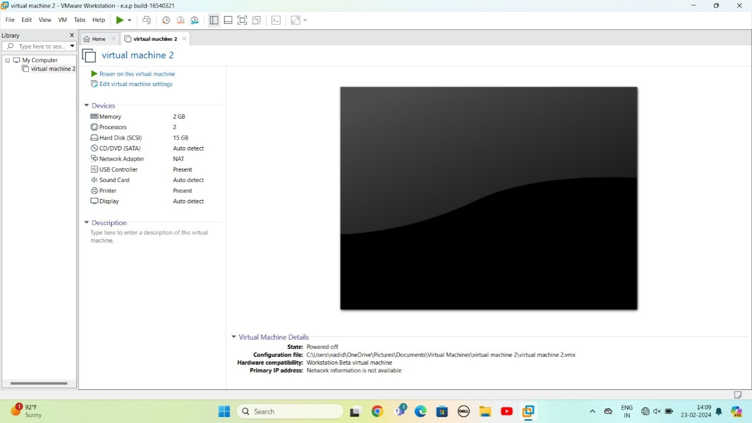

STPE 9: CLONE THE CREATED SOFTWARE

GOTO VM SELECT OPTION MANAGE

IN THAT SELECT CLONE

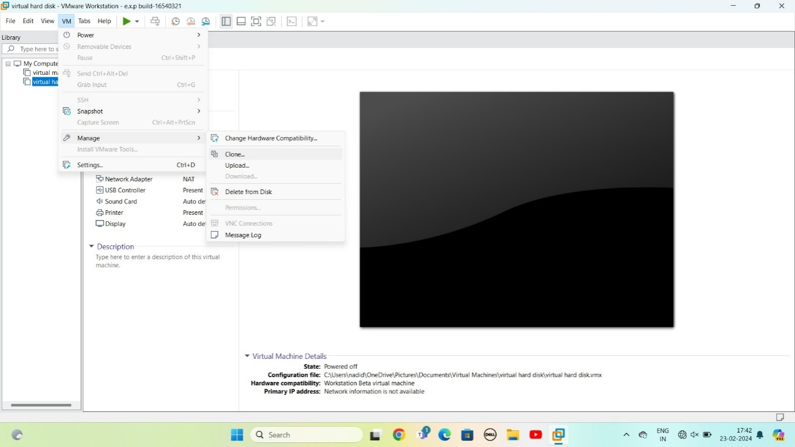

STEP 10: Select clone from

Give next

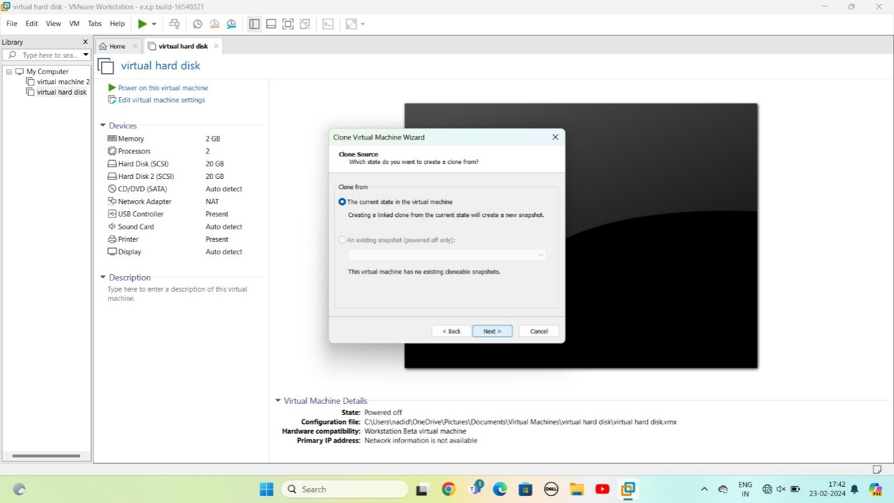

STEP 11: select clone type

Give next

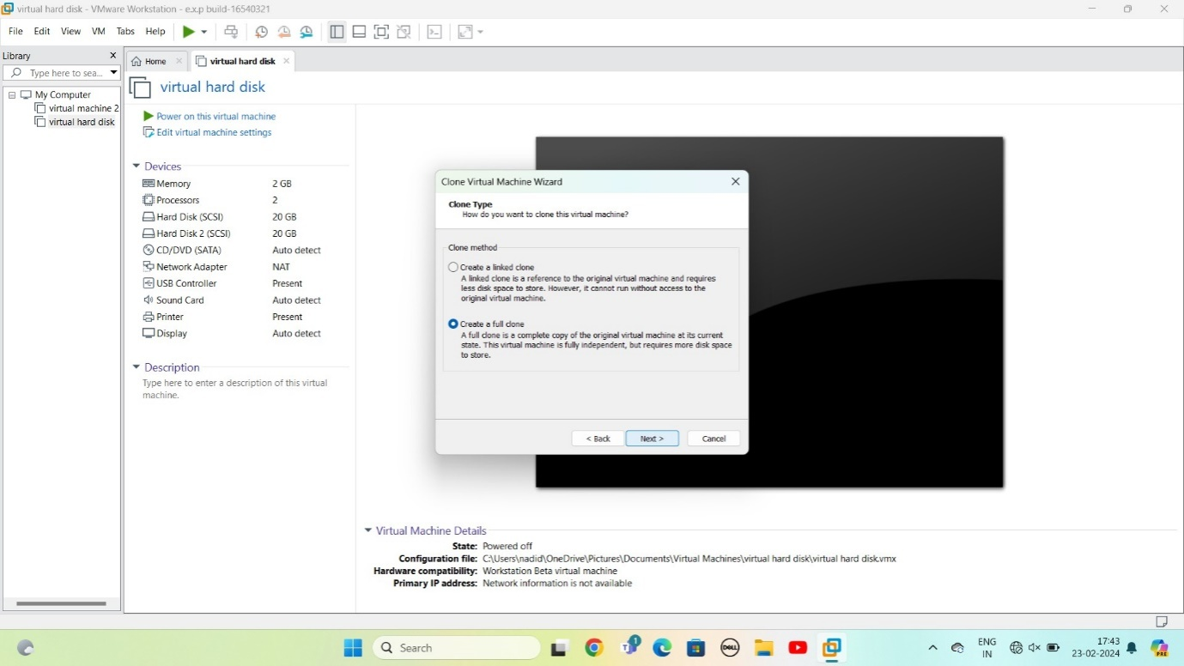

STEP 12: SELECT NAME OF VIRTUAL MACHINE

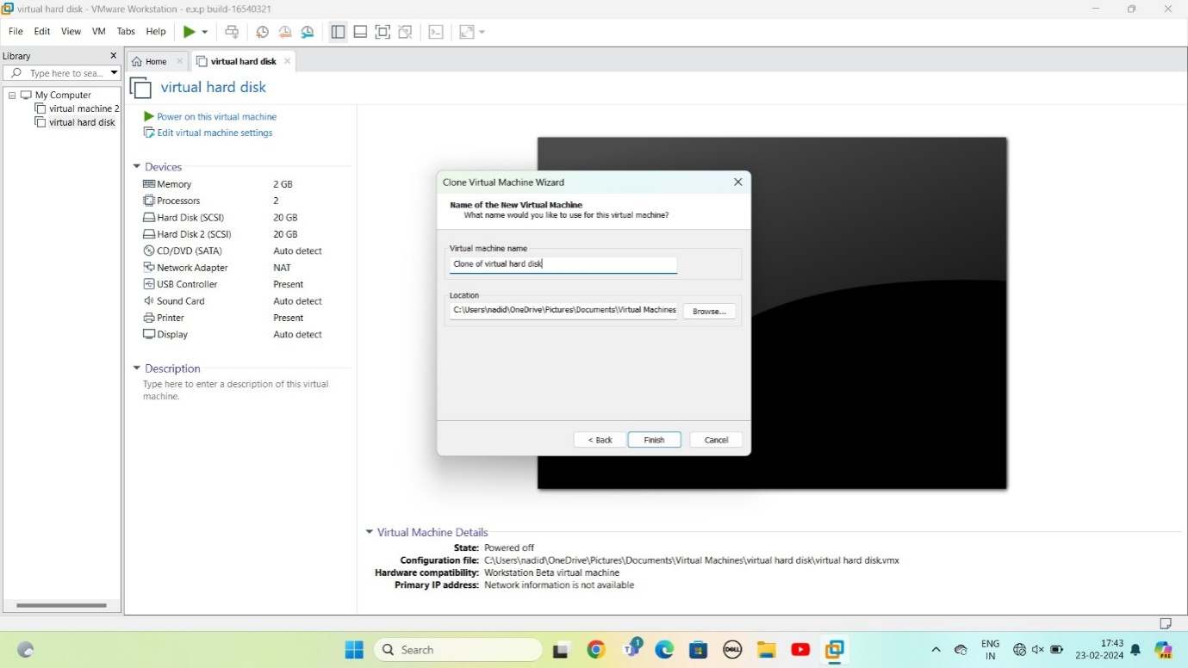

STEP 13: cloning virtual machine is ready

Give close

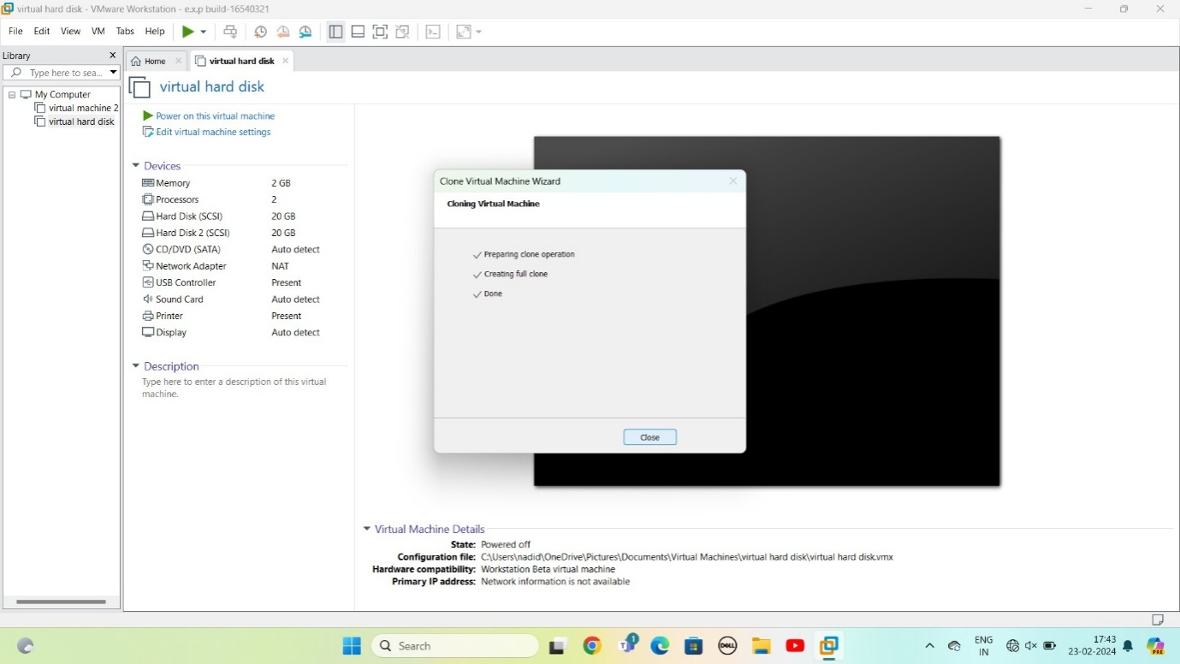

STEP 14: cloning virtual machine is ready

